Learn Ansible by doing

<https://learn.acloud.guru/course/e7251e47-a643-49f3-b096-28072dfa577b/dashboard>

Chapter2 adhoc commands

File module

<https://docs.ansible.com/ansible/latest/collections/ansible/builtin/file_module.html>

>ansible -m file -a “path=/path/to/directory state=directory owner=userid group=groupname mode=0755” all

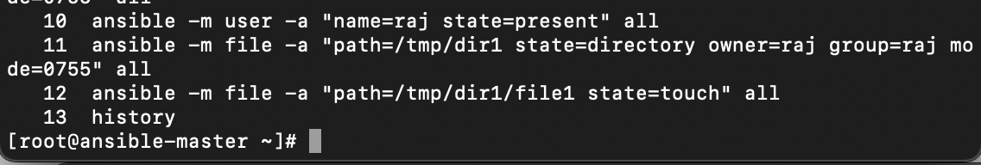

State= directory to create a directory

State=touch to create a file

Copy module

>ansible -m copy -a “src=/path/to/file/in/controller dest=/dest/folder/path” all

Using httpd.conf file as a template to listen on different ports

(dev:80 test:90)

Template Module

Copying the httpd conf file into the master ansible to use as a template

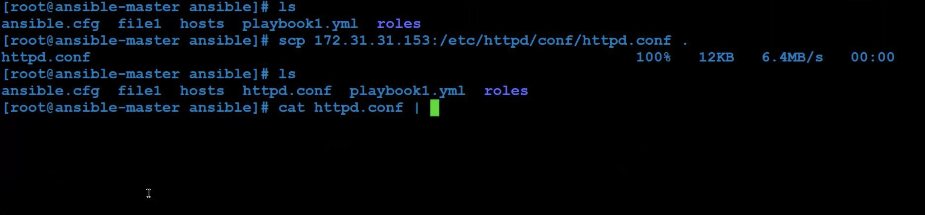

Removing the hard coded 80 value in httpdconf file and assigning a variable {{ portno }} to it { also changed the user value from apache to {{ username }}

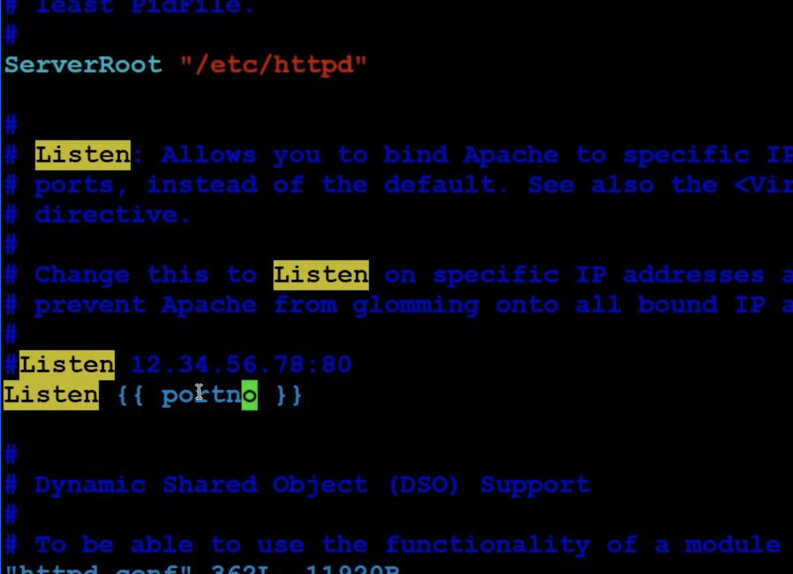

Ansible-master playbook file

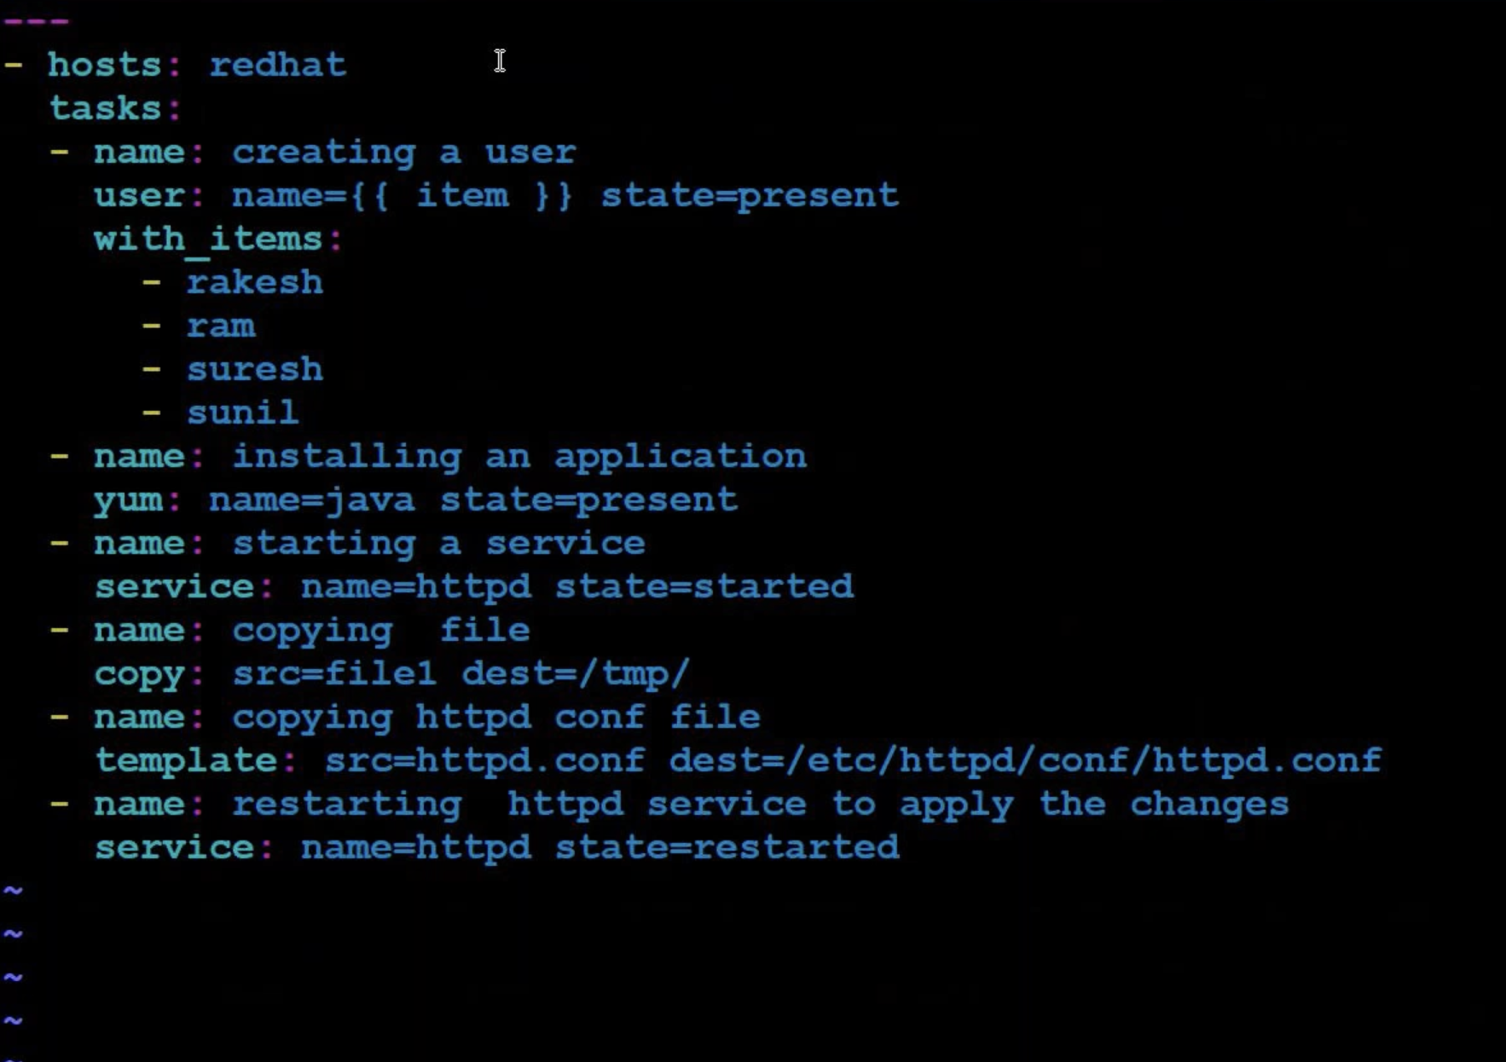

Make sure to create that user you want to mention {tes-ansible}

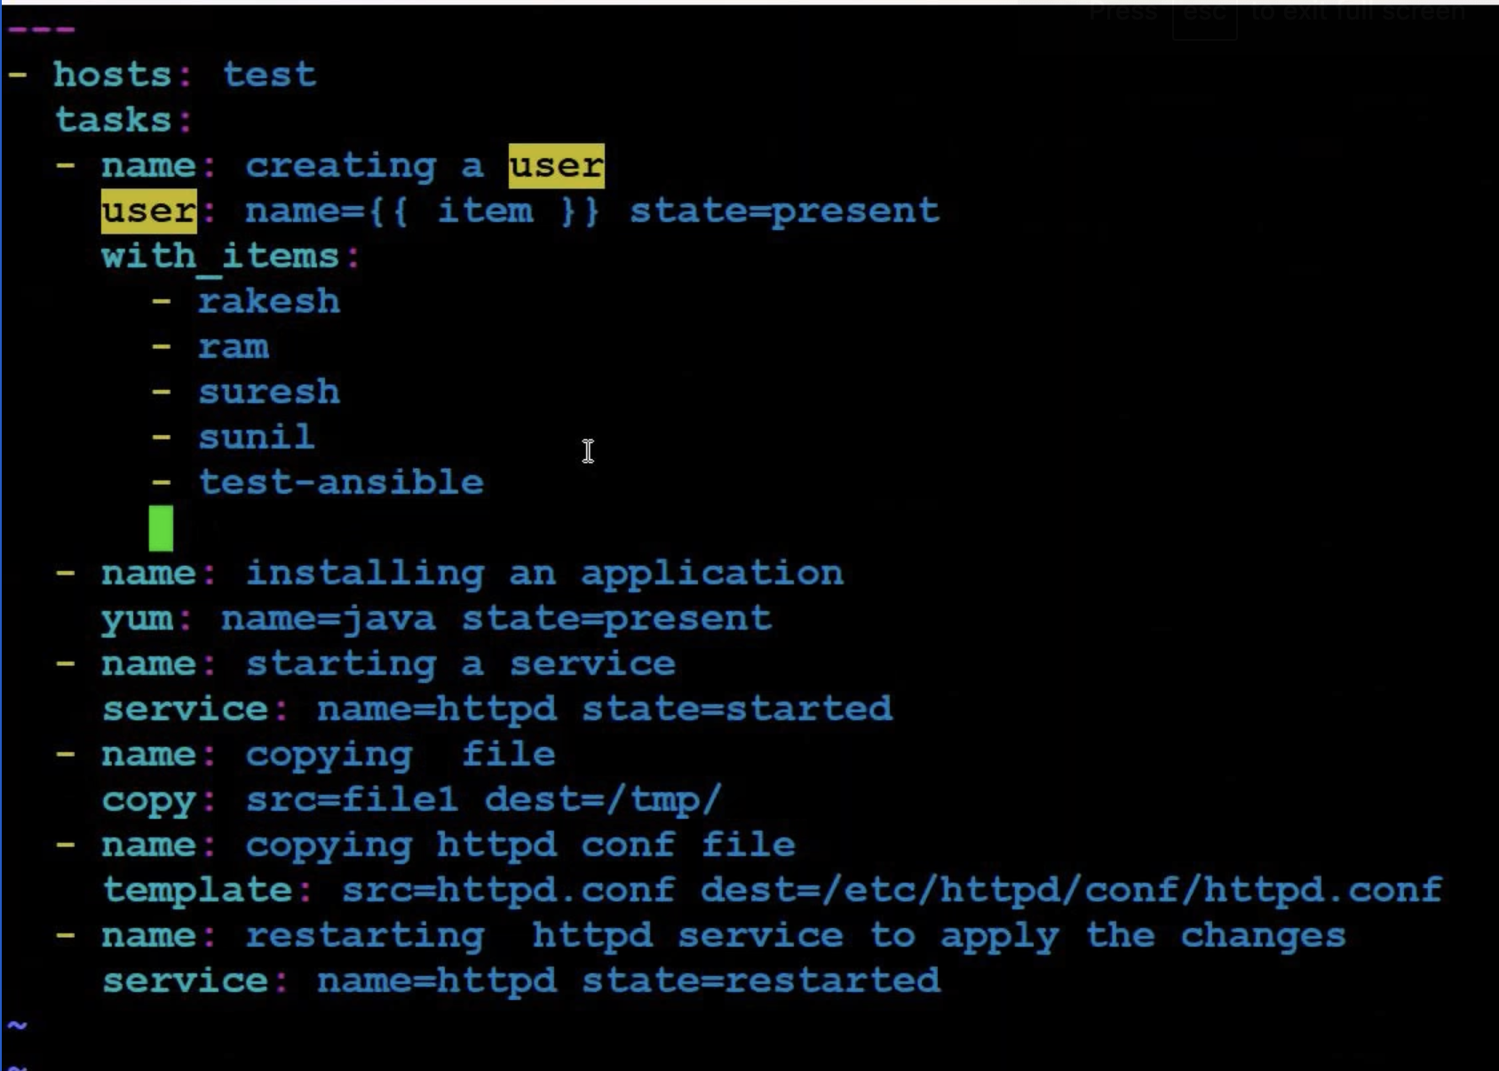

>>ansible-playbook playbook1.yml --extra-vars=”portno=100” --extra-vars=”username=test-ansible”

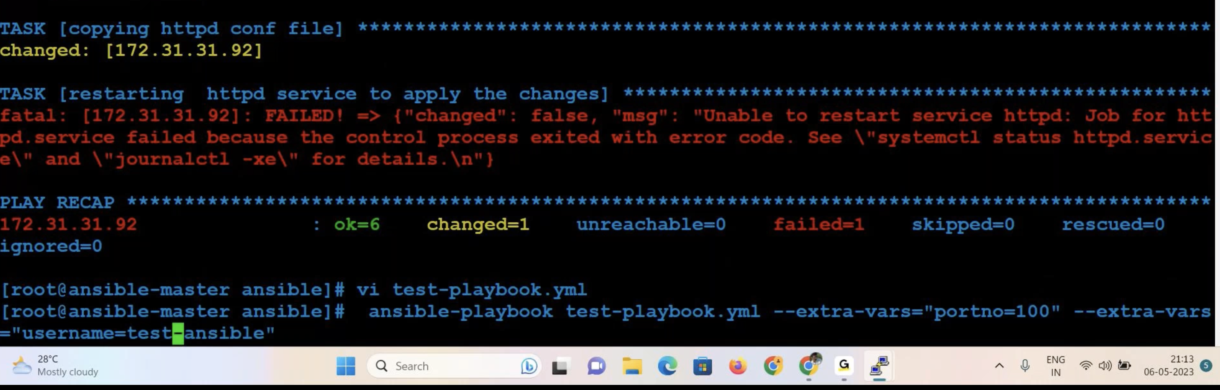

get_url module

<https://docs.ansible.com/ansible/latest/collections/ansible/builtin/get_url_module.html>



url given is a sample url to some page

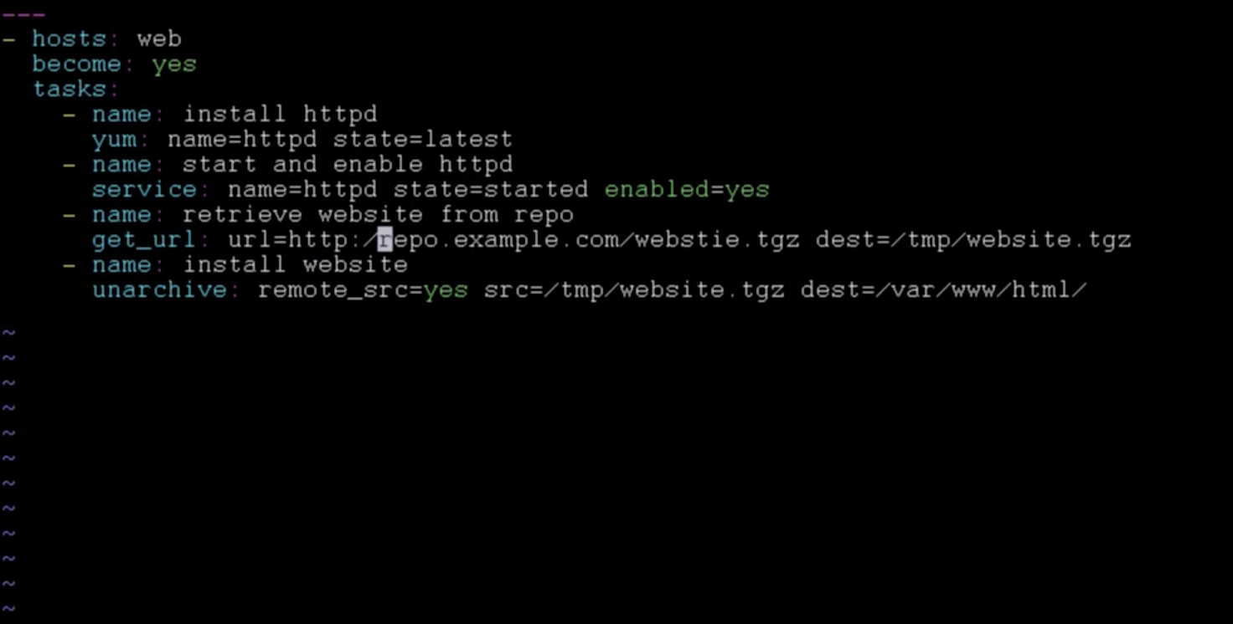

Copying the get_url downloaded file to html index.html page

<https://www.sample.com/>

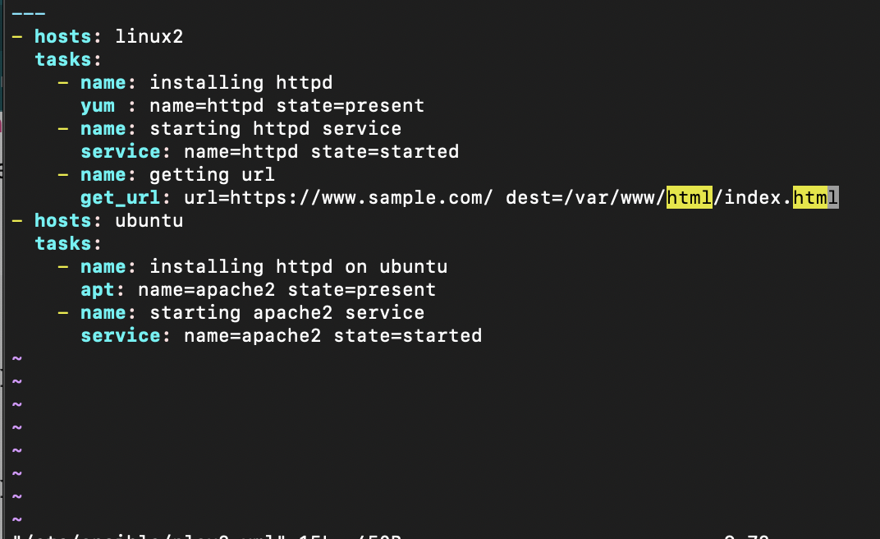

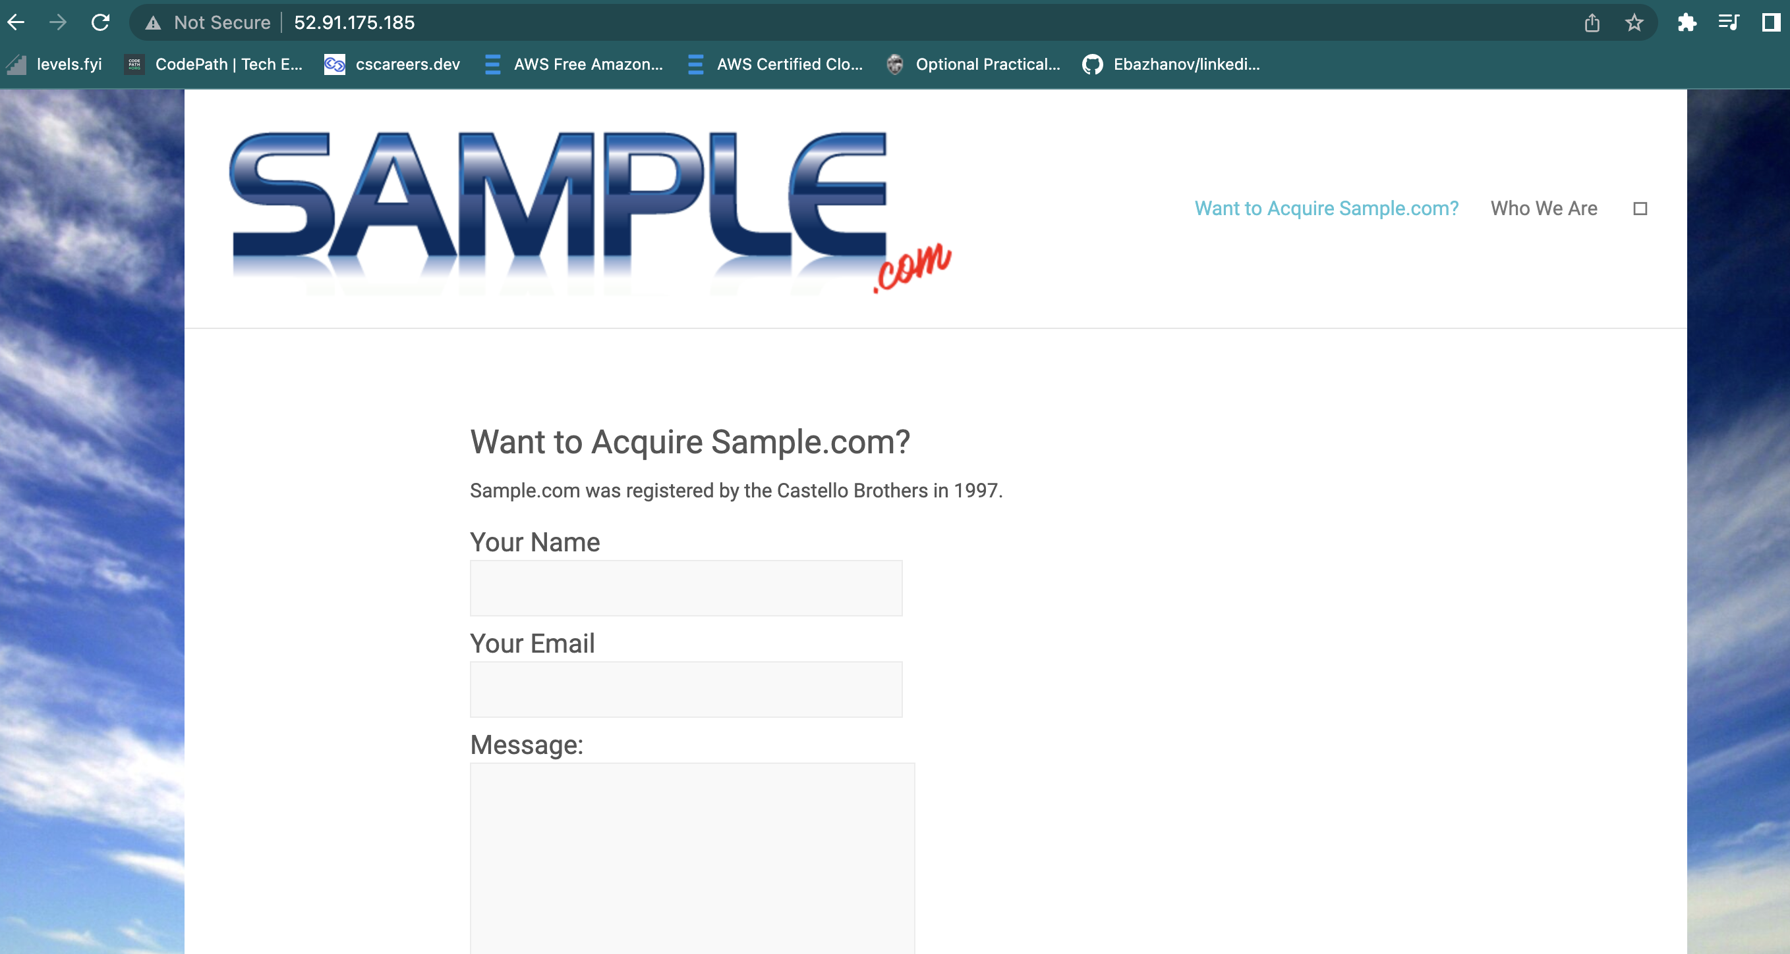

Debug module using block and rescue

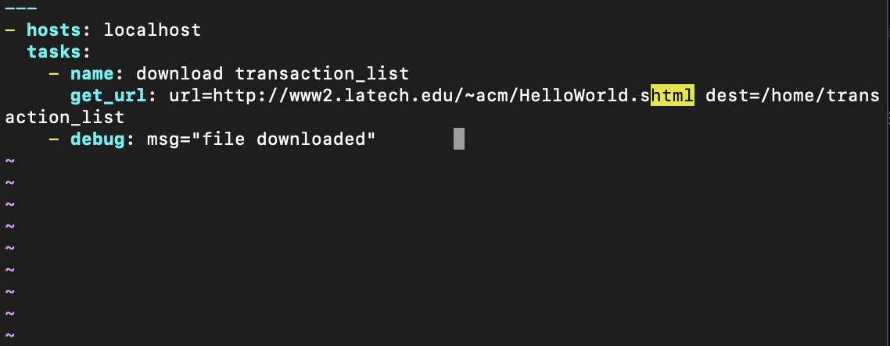

Prints a message if the task is completed

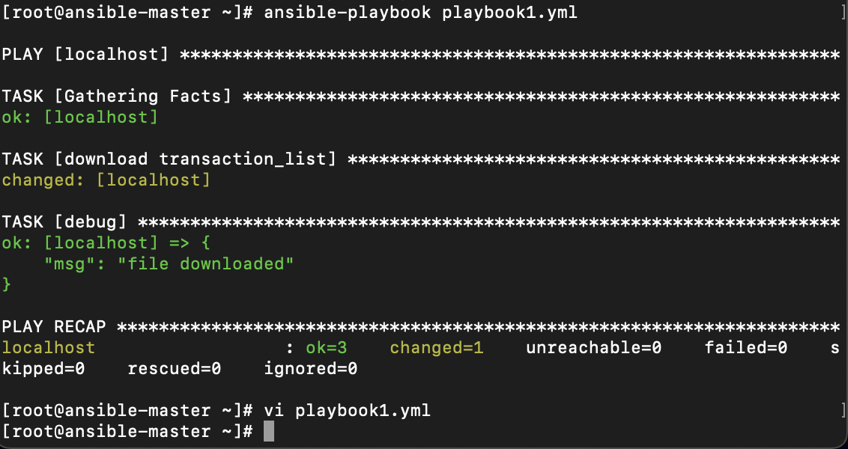

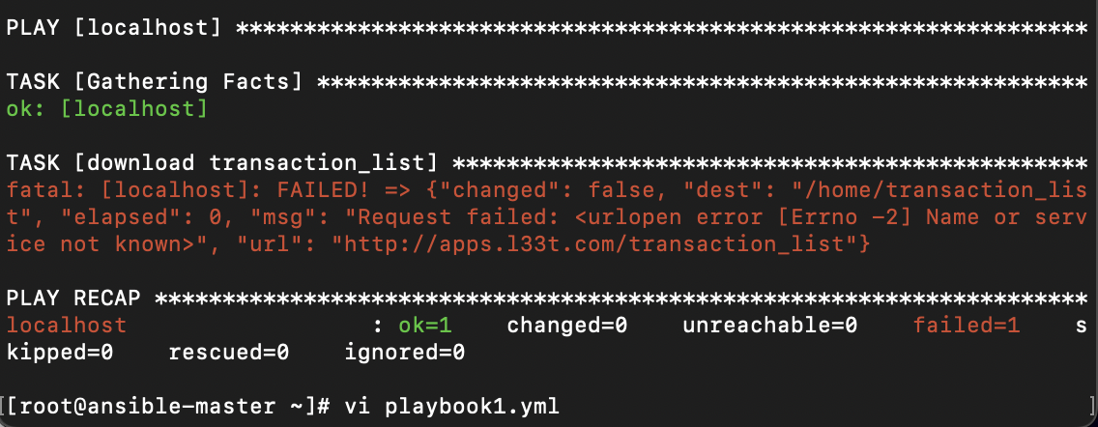

Did not print the message as the task is failed

<http://apps.l33t.com/transaction_list>  The above link doesnot work but to show how to debug it.

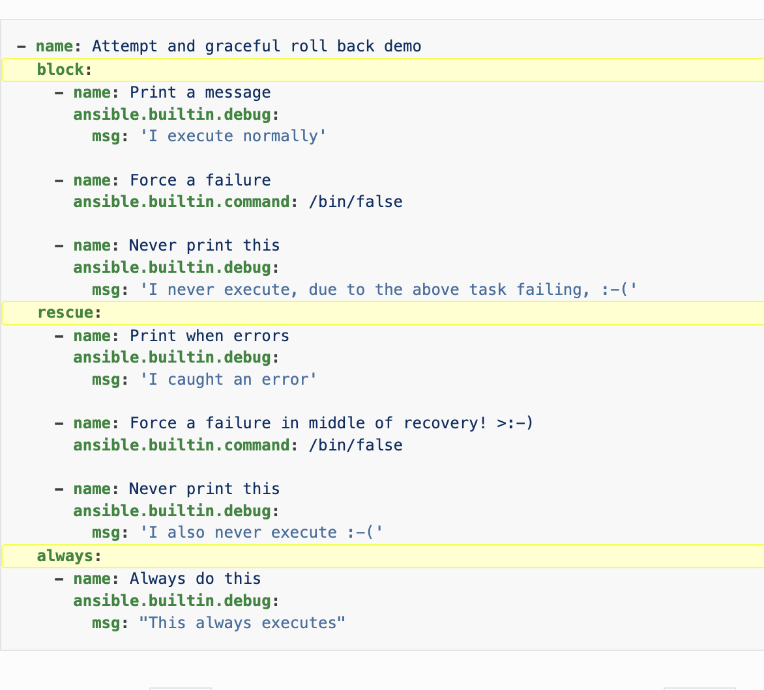

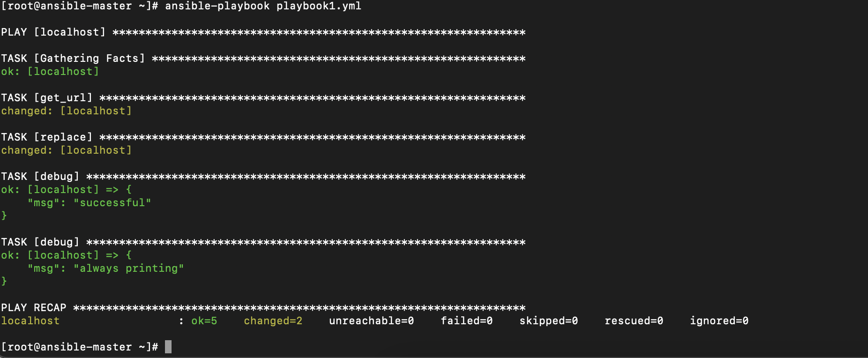

Replace module

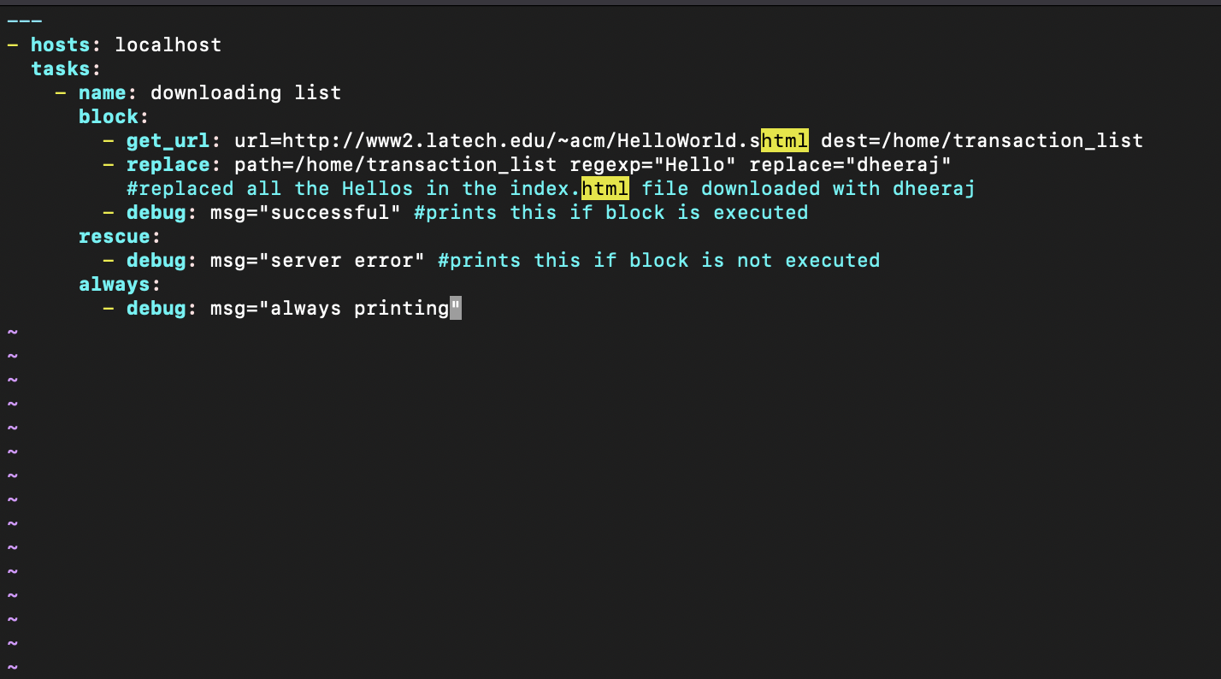

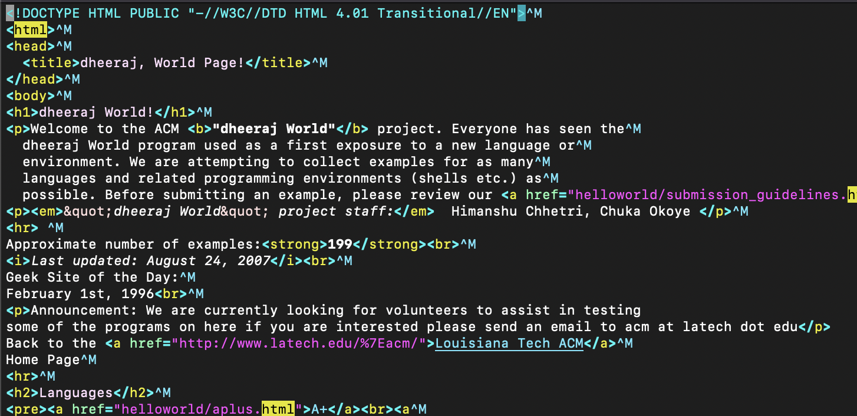

Working with Ansible Templates, Variables, and Facts

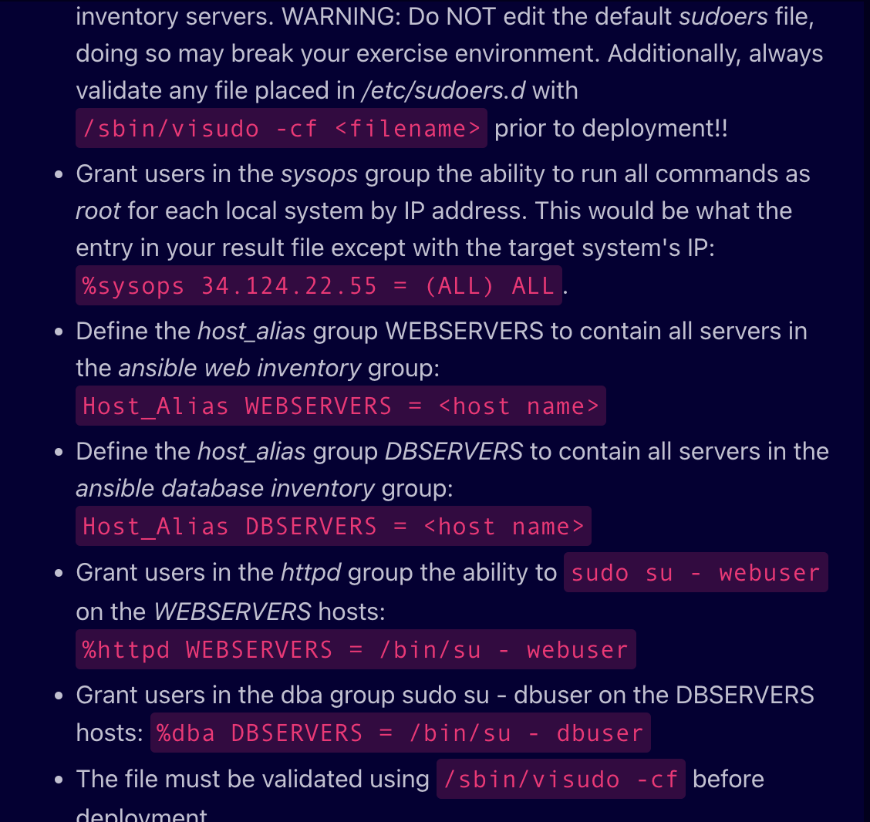

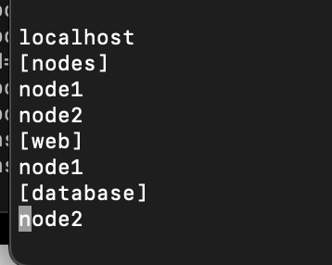

Hosts in /etc/ansible/hosts

Giving a specific group sudo permissions in specific hosts address

Giving host alias for the group of hosts in ansible hosts file

<Grant users in the httpd group the ability to sudo su - webuser on the WEBSERVERS hosts:

Hardened.j2 file j2 is extension for janga2 files simple template files that store variables that can change from time to time. When Playbooks are executed, these variables get replaced by actual values defined in Ansible Playbooks.

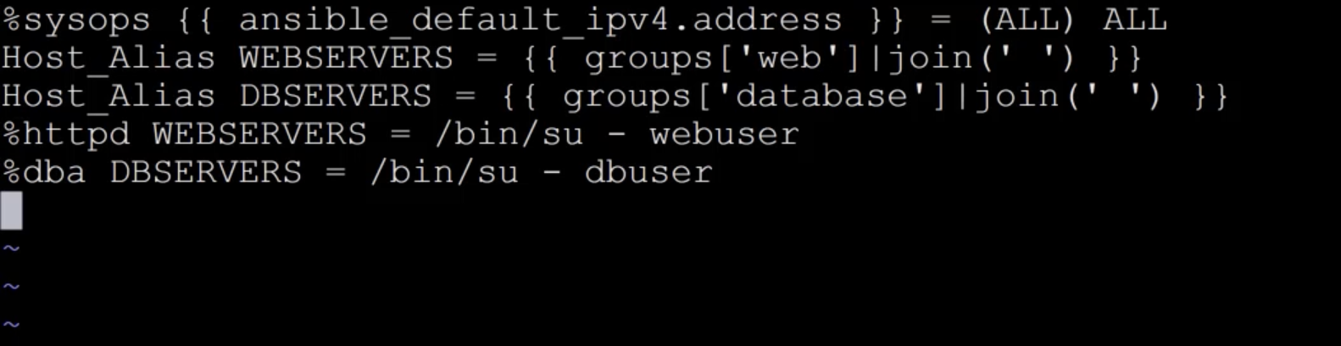

Playbook.yml

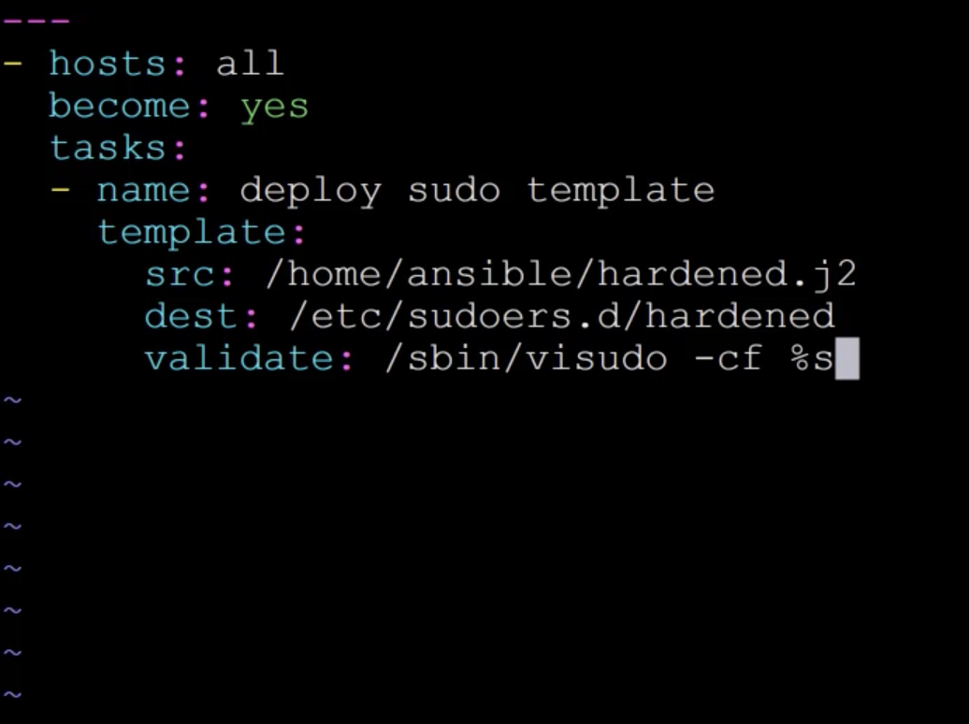

Line in file module:

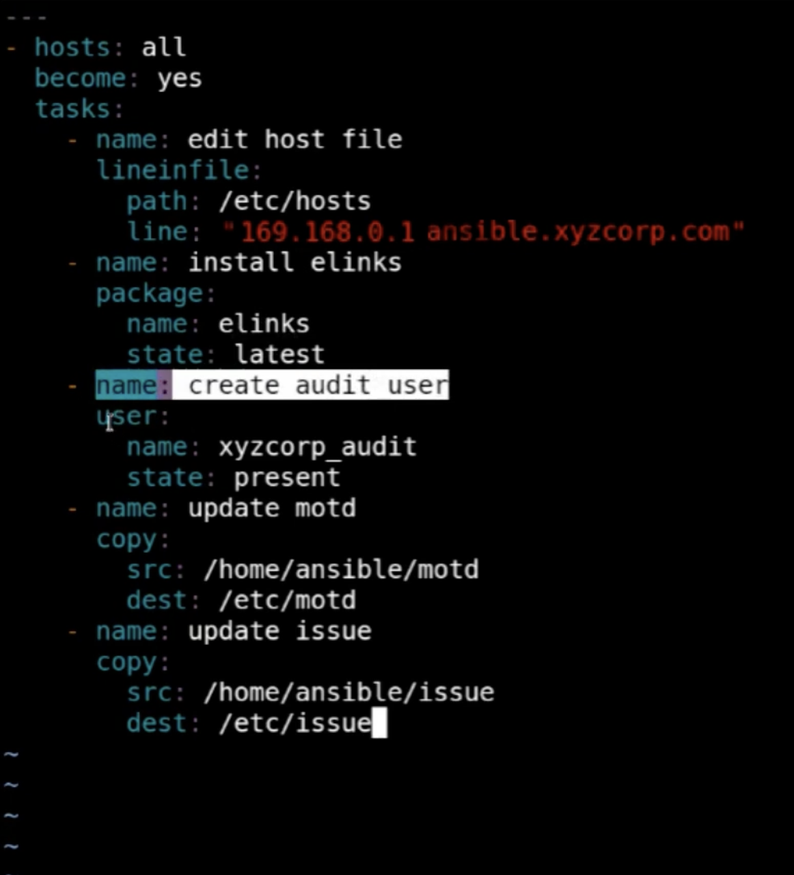

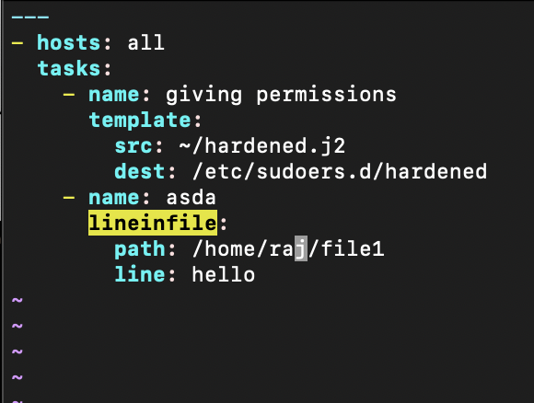

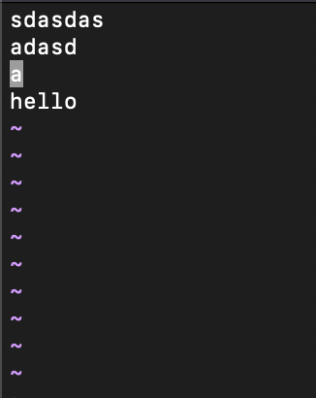

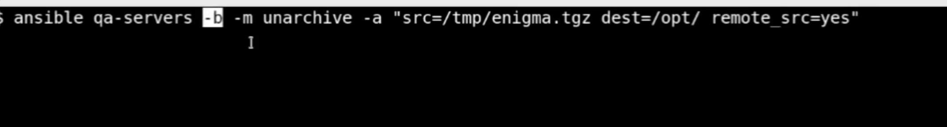



-b flag to become root